**Hands on 1**

**Spring Data JPA - Quick Example**

**application.properties:**

# Spring Framework and application log

logging.level.org.springframework=info

logging.level.com.cognizant=debug

# Hibernate logs for displaying executed SQL, input and output

logging.level.org.hibernate.SQL=trace

logging.level.org.hibernate.type.descriptor.sql=trace

# Log pattern

logging.pattern.console=%d{dd-MM-yy} %d{HH:mm:ss.SSS} %-20.20thread %5p %-25.25logger{25} %25M %4L %m%n

# Database configuration

spring.datasource.driver-class-name=com.mysql.cj.jdbc.Driver

spring.datasource.url=jdbc:mysql://localhost:3306/ormlearn

spring.datasource.username=root

spring.datasource.password=mysql

# Hibernate configuration

spring.jpa.hibernate.ddl-auto=validate

spring.jpa.properties.hibernate.dialect=org.hibernate.dialect.MySQL5Dialect

**com.cognizant.orm-learn.model.Country:**

package com.cognizant.orm_learn.model;

import javax.persistence.Column;

import javax.persistence.Entity;

import javax.persistence.Id;

import javax.persistence.Table;

@Entity

@Table(name = "country")

public class Country {

@Id

@Column(name = "co_code")

private String code;

@Column(name = "co_name")

private String name;

public String getCode() {

return code;

}

public void setCode(String code) {

this.code = code;

}

public String getName() {

return name;

}

public void setName(String name) {

this.name = name;

}

@Override

public String toString() {

return "Country [code=" + code + ", name=" + name + "]";

}

}

**com.cognizant.orm-learn.CountryRepository:**

package com.cognizant.orm_learn;

import org.springframework.data.jpa.repository.JpaRepository;

import org.springframework.stereotype.Repository;

import com.cognizant.orm_learn.model.Country;

@Repository

public interface CountryRepository extends JpaRepository<Country, String> {

}

**com.cognizant.orm-learn.service.CountryService:**

package com.cognizant.orm_learn.service;

import java.util.List;

import javax.transaction.Transactional;

import org.springframework.beans.factory.annotation.Autowired;

import org.springframework.stereotype.Service;

import com.cognizant.orm_learn.model.Country;

import com.cognizant.orm_learn.CountryRepository;

@Service

public class CountryService {

@Autowired

private CountryRepository countryRepository;

@Transactional

public List<Country> getAllCountries() {

return countryRepository.findAll();

}

}

**OrmLearnApplication.java:**

package com.cognizant.orm_learn;

import java.util.List;

import org.slf4j.Logger;

import org.slf4j.LoggerFactory;

import org.springframework.boot.SpringApplication;

import org.springframework.boot.autoconfigure.SpringBootApplication;

import org.springframework.context.ApplicationContext;

import com.cognizant.orm_learn.model.Country;

import com.cognizant.orm_learn.service.CountryService;

@SpringBootApplication

public class OrmLearnApplication {

private static final Logger *LOGGER* = LoggerFactory.*getLogger*(OrmLearnApplication.class);

private static CountryService *countryService*;

public static void main(String[] args) {

ApplicationContext context = SpringApplication.*run*(OrmLearnApplication.class, args);

*countryService* = context.getBean(CountryService.class);

*LOGGER*.info("Inside main");

*testGetAllCountries*();

}

private static void testGetAllCountries() {

*LOGGER*.info("Start");

List<Country> countries = *countryService*.getAllCountries();

*LOGGER*.debug("countries={}", countries);

*LOGGER*.info("End");

}

}

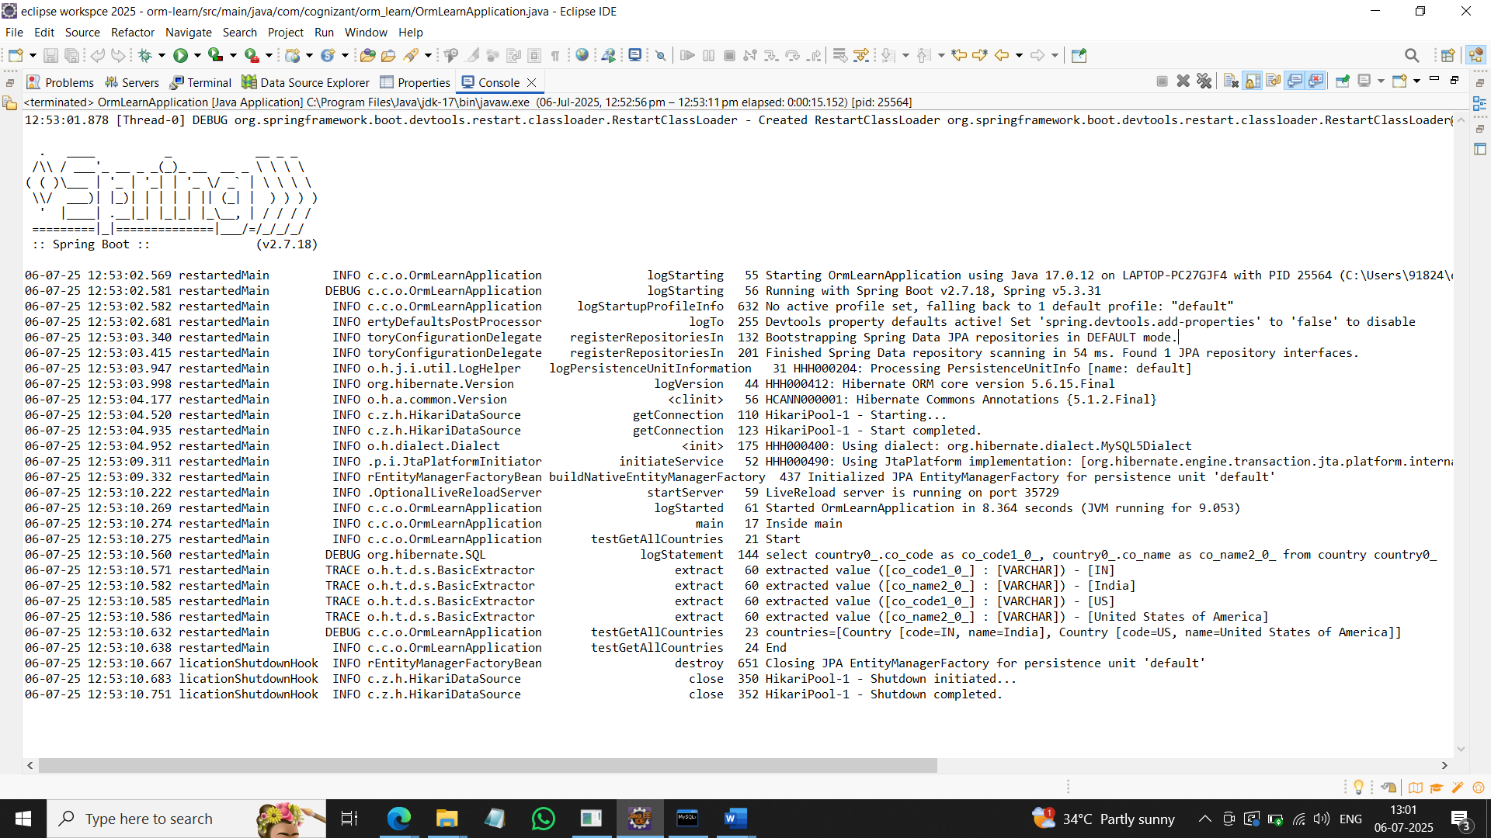

**Hands on 4**

**Difference between JPA, Hibernate and Spring Data JPA**

**Hibernate**

**Employee.java:**

package com.cognizant.orm_learn.model;

import javax.persistence.*;

@Entity

@Table(name="employee")

public class Employee {

@Id

@GeneratedValue(strategy = GenerationType.*IDENTITY*)

private int id;

private String name;

private double salary;

public int getId() {

return id;

}

public void setId(int id) {

this.id = id;

}

public String getName() {

return name;

}

public void setName(String name) {

this.name = name;

}

public double getSalary() {

return salary;

}

public void setSalary(double salary) {

this.salary = salary;

}

@Override

public String toString() {

return "Employee [id=" + id + ", name=" + name + ", salary=" + salary + "]";

}

}

**Spring Data JPA  
EmployeeRespository.java:**

package com.cognizant.orm_learn.repository;

import org.springframework.data.jpa.repository.JpaRepository;

import org.springframework.stereotype.Repository;

import com.cognizant.orm_learn.model.Employee;

@Repository

public interface EmployeeRepository extends JpaRepository<Employee, Integer> {

}

**EmployeeService.java:**

package com.cognizant.orm_learn.service;

import org.springframework.beans.factory.annotation.Autowired;

import org.springframework.stereotype.Service;

import org.springframework.transaction.annotation.Transactional;

import com.cognizant.orm_learn.model.Employee;

import com.cognizant.orm_learn.repository.EmployeeRepository;

@Service

public class EmployeeService {

@Autowired

private EmployeeRepository employeeRepository;

@Transactional

public void addEmployee(Employee employee) {

employeeRepository.save(employee);

}

}

**OrmLearnApplication.java:**

package com.cognizant.orm_learn;

import java.util.List;

import org.slf4j.Logger;

import org.slf4j.LoggerFactory;

import org.springframework.boot.SpringApplication;

import org.springframework.boot.autoconfigure.SpringBootApplication;

import org.springframework.context.ApplicationContext;

import com.cognizant.orm_learn.model.Country;

import com.cognizant.orm_learn.model.Employee;

import com.cognizant.orm_learn.service.CountryService;

import com.cognizant.orm_learn.service.EmployeeService;

@SpringBootApplication

public class OrmLearnApplication {

private static final Logger *LOGGER* = LoggerFactory.*getLogger*(OrmLearnApplication.class);

private static CountryService *countryService*;

private static EmployeeService *employeeService*;

public static void main(String[] args) {

ApplicationContext context = SpringApplication.*run*(OrmLearnApplication.class, args);

*countryService* = context.getBean(CountryService.class);

*employeeService* = context.getBean(EmployeeService.class);

*LOGGER*.info("Inside main");

*testGetAllCountries*();

*testAddEmployee*();

}

private static void testGetAllCountries() {

*LOGGER*.info("Start");

List<Country> countries = *countryService*.getAllCountries();

*LOGGER*.debug("countries={}", countries);

*LOGGER*.info("End");

}

private static void testAddEmployee() {

*LOGGER*.info("Start testAddEmployee");

Employee employee = new Employee();

employee.setName("John");

employee.setSalary(50000);

*employeeService*.addEmployee(employee);

*LOGGER*.info("End testAddEmployee");

}

}

